Windsor Miners
25th March 2022



PROJECT PROPOSAL

Counter Strike: GO
Phase 1: EDA Analysis

Suhail Riyaz Ahmed
Raj Bharatkumar Bhalodwala
Bhavesh Trigunanand Mishra
Luis Palacios Melendez
Dhruvalbhai Sunilkumar Patel
Amit Sharma – Group Leader

1. Introduction 3
2. Needs/Problems 4
3. Goals/Proposal 5
4. EDA aNalysis 6
5. GIT SETUP 11
6. REFERENCES 11

- Introduction

Counterstrike is a First-Person Shooter (FPS) game in which two teams of five players face each other in a matchup. The game includes a Terrorist side (T) that is tasked to plant a bomb and have it detonated, and a Counter-Terrorist side (CT) that is tasked to defuse the bomb or prevent it from being planted.
The game of Counterstrike is a best of thirty rounds, the winning team being the first to win sixteen rounds. The thirty rounds are played in two halves of fifteen on each side of the map. There are seven maps in the map pool that are available to be played competitively at any given time. Matches are normally played as a 'bo3' (Best of 3) maps, with finals often played as 'bo5’s. Counterstrike also has an economic system that governs the acquisitions of armour, weapons, and grenades by the players.

Motivation:
Online gaming world is full of First-Person Shooter games, with CS: GO being one of the most sorted out game by online players/gamers. Most players (old or new) try to get along on the platform and try to hone their skills (either offensive or defensive) by playing competitive matches.
But the other side of the story is that CS: GO platform has the highest dropout rate for new/beginner online gamers. With the game and maps becoming increasingly competitive and complex it becomes extremely difficult for a new gamer to keep on going on the platform after certain time on the platform. Beginners often lose interest as they face tough teams, maps and game styles which sometimes do not suit either the skill level or the playing strategy of the beginner.

- Need/Problem

Beginner level Gamers starts enthusiastically on the Gaming platform but soon found wanting on the skills and the strategy level. The game has complex maps and mechanics, which are need thorough knowledge and tactics to master the area, on top there is style of play (either offensive or defensive) which drives the success rate for a player or team.
Often new gamers play for few days and as the game is tough, they lose a lot of initial matches, which in turn triggers the DROP-OUT tendency for the new gamer. Who likes Losing? – and thus the interest levels go down for the inexperienced players. Also, players do not get a hang of game styles for a specific map. There is always a missing piece of the puzzle where the new gamer misses success (Map, Style, Economics, Skills etc.)
They need upfront guidance and insights for starting their online game journey. These insights can help the gamers to choose better maps, learn from top players/teams and use strategies (economic) that can raise their own interest in this complex gameplay. Eventually the gamer can perfect his own style of gameplay (offensive or defensive) by learning or copying from the absolute best around on the circuit.

- Goals/Proposal

The team will take a descriptive analysis approach in which team will try to develop an analytic product to examine the data from a dataset which is pulled from a specific timeline and containing professional match data for players, teams and maps for Counter Strike: Global Offensive online game/tournament.
This data can help Beginner level online gamers to gain insights related to the past trends for the online tournament games which can help them to gain strategic edge while starting their new online journey.

Beneficiaries
- New gamers will be direct beneficiaries of the analytic trend data to understand game, maps, styles and economics.
- Game Creators will be indirectly benefitted by having better retention percentage for beginner level players – hence retaining new customers.

The analysis will try to give answers to some of the below few questions: -
- Which maps get most picked with high number of kills per round?
- Which are the top players in an event and can decided awards for MVP?
- Which countries/continents supply the best and most of the players?
- Where to start and what approach to take on a certain map?

- EDA Analysis

The data is split into 5 tables that store data related to:
- Economy - contains record or every match game by date and event. Data table recollect records of match economy scored by team 1 and team 2 at the end of every round.
- Picks – contains record of order of map picks and vetoes in the map selection process. Data table recollect records of maps eliminated by team 1 and team 2 in each game to select playing map.
- Players - information of individual performances of players on each map. Data table recollect records of performance in terms of kills, assist, deaths, headshots, Kast (Percent of round the player killed, assisted, survived or was traded), kills-death difference, average damage per round, first kills - first deaths, and rating in match in three different maps.
- Events – contains data related to esports events held worldwide along with the type of event and country
- Results – contains the results of each game/match played by the teams, it contains full details on styles, strategy, map and winner details
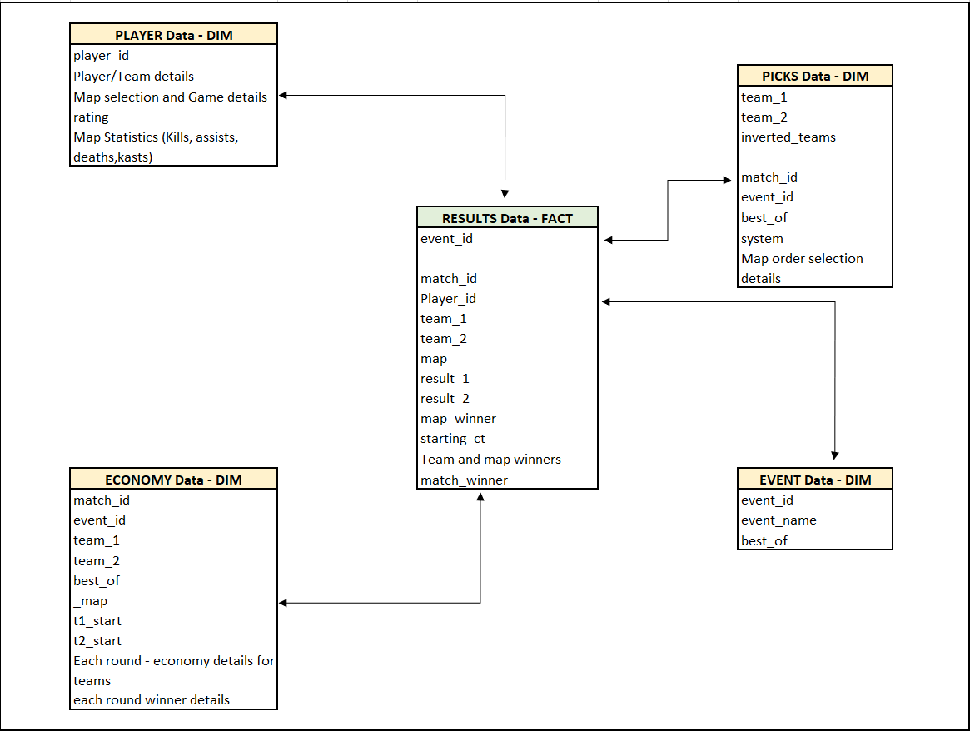

Values stored in 'eventid' and 'matchid' columns are unique for each match and event and shared between tables, so these columns can be used as keys to merge data between tables. It is necessary to note that the rows in the 'results' and 'economy' tables store data for each map played in a match, while the rows in 'picks' and 'players' table store data for the entire match. Matches were recorded in a range from 11/2015 to 03/2020. This data was scraped off https://www.hltv.org/ and from that they collected individual performance of player.
Whole Dataset contains a total of 236 columns across sheets, with maximum columns being Decimal and Integer values (196 in total), these variables are more of continuous in nature with very few of categorical values. Of the 27 String columns many are repeated across sheets to maintain a connectivity in them. The last category contains Date fields and Boolean fields to maintain the timeline and yes/no type answers
Invalid and Missing values
Most of the fields have valid records, there's some fields of t1_removed_3, t2_removed_3, t1_picked_1, m2_kast and t2_picked_1 with some missing values, because the game consists of best of 3 rounds. Player names and some text fields have invalid records (symbols, nulls and blanks). Some columns in specific maps have missing values, because data is collected based on performance in three maps
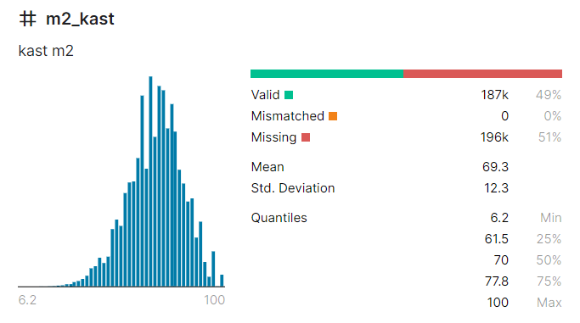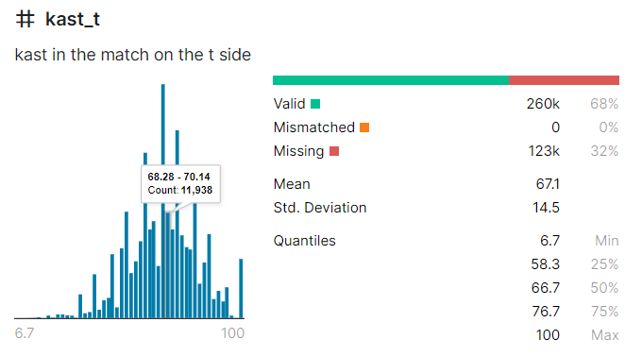
Outliers (with Graphs)
Outlier identification was done on all the columns of the csv files, with most of the fields not showing outlier behavior but some of the columns like Kast, M1_Kast,1_t1 and some more showed values which were outside the trend of the maximum values in that area. Below are some of the analysis graphs which were produced to be part of the analysis done by the team.
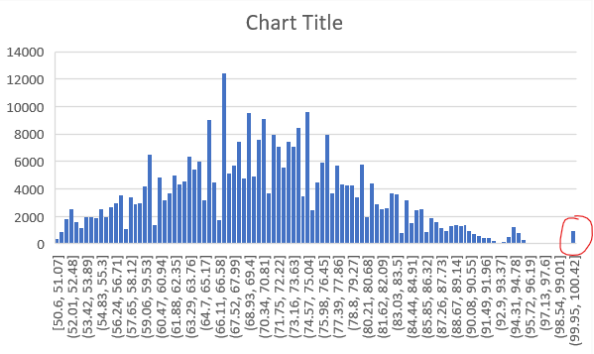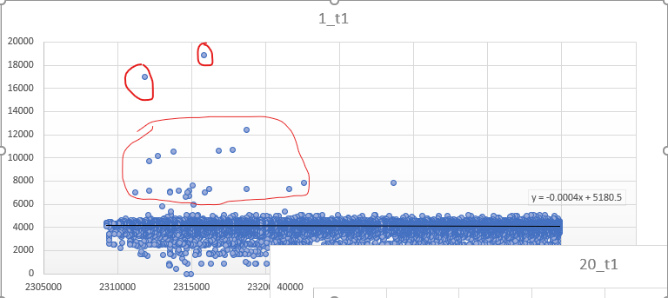

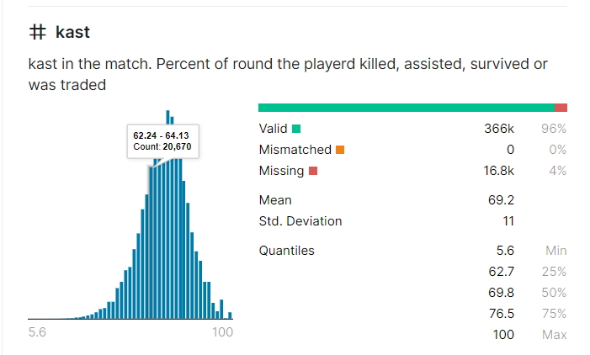
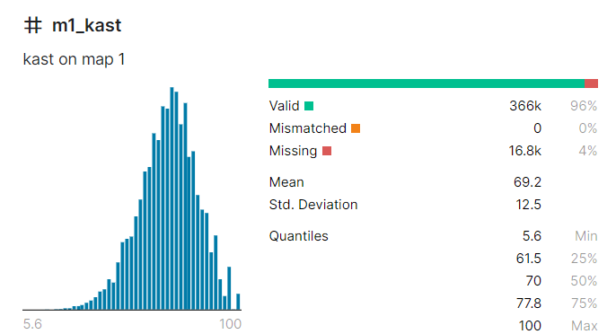

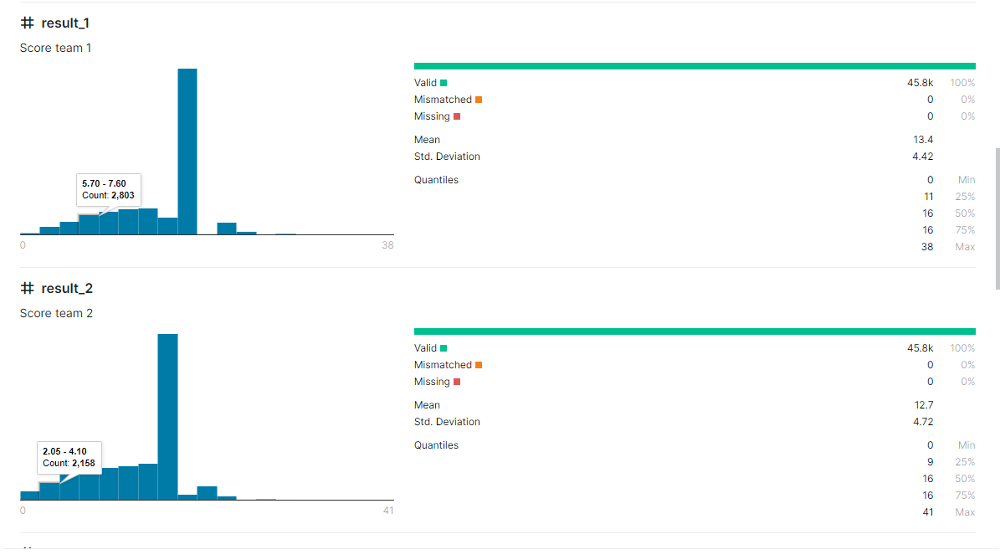

Graphs above clearly depicts the presence of Outliers – marked in Red, many columns were pulled into histograms, bar plots and scatter plots to know the spread of the values and identify the outliers – out of all some are depicted above
Segmentation
To some extent segmentation is present in the data, for instance players are grouped into teams and teams are grouped under countries. Apart from these major one’s events are one big group/segment with team and country data
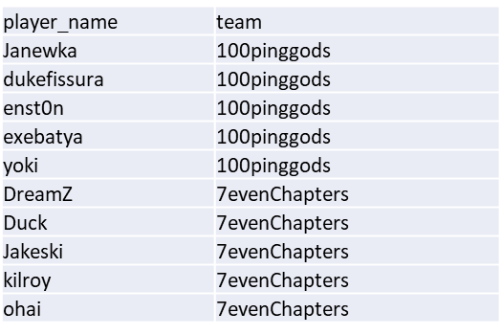
Data Imbalance
Most of the data in the data elements is in balanced state with very few exceptions like winning margin for the teams – hardly any teams won like 15-0 in a match, mostly the games have gone to the wire and are really on close margins

Correlations
In some of the data sheets correlation is present specially in the economy part of the game is driven by the match results for each round. The more you win, the better balances you have on the economy scales same goes the other way in case of loses.
Tentative/Preliminary Visualizations
At the start of the document certain questions were tried to put up for outcomes that can be derived from the data set through medium of visualizations - data will be grouped, cleansed, filtered and aggregated to find out the answers to the below major questions
- Which maps get most picked with high number of kills per round?
- Which are the top players in an event and can decided awards for MVP?
- Which countries/continents supply the best and most of the players?
- Where to start and what approach to take on a certain map?

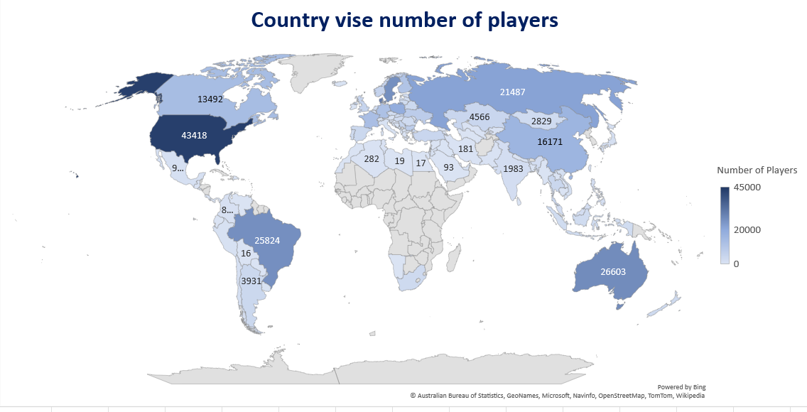
The above visualization* tries to show a geographic spread of the players across the globe, the above data can be sliced and diced further to get country level stats or grouping the data to top players
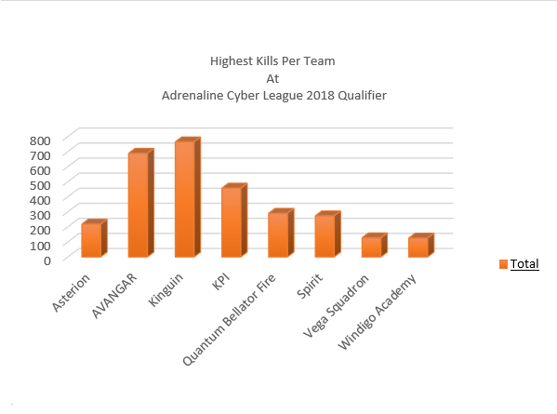
The above visualization* tries to depict the top offensive players (on number of kills) on their individual teams participating in a certain league. This type of data is important to identify the top player on a team – the data can be used to either target the player or to adopt a ‘stay away’ policy from him.
*Visualizations are still tentative, and look/feel can change once they are created using actual tool

- Data Cleaning and Transformation

The whole Dataset is divided in 5 parts (namely: Economy, Picks, Players, Events and Results) – Result is the main Fact table which can be used to pull out most of the visualization from the tool. To create these visualizations, these tables/csv’s need to be Data cleaned and formalized in a certain way (combined data frames) so that visualizations are more clear, easy to make, meaningful and less redundant. Below are the few major actions that were taken on the source data to create a cleaner, thinner, meaningful, and concise data frames for loading in Tableau.

Players Dataset: 13 Changes in Total were put on this table, the original raw dataset had 380K rows and 101 columns which after cleanup were trimmed to 133K rows and 84 columns
- Data Type standardization: Country field made standard (for geographic distributions), Date and time changed to Dates
- Removing Unwanted Fields/columns: Some statistics related to assists were removed as the visualization is more focus on Offensive and defensive strategies
- Filter rows/Conditions: Certain NULL values, Typos, and unwanted values e.g.: country like ‘Others’ was removed to bring the dataset to a manageable size. Also, a common condition is put on the whole dataset to pick only Best of 3 matches for consideration for the visualization. Also, Non-Standard Team names (only special characters and irregular names) were also filtered out.

Events Dataset: 4 Changes in Total were put on this table, the original raw dataset had 4.4K rows and 3 columns which after cleanup were trimmed to 3.2K rows and 3 columns. Data set was more or less in very good shape; hence very few changes were done as a part of cleanup.
- Filter rows/Conditions: NULL values in even names were taken care, common condition is put on the whole dataset to pick only Best of 3 matches for consideration for the visualization to bring the dataset to a manageable size. There were also blank spaces at the end in Even names – which were trimmed.

Economy Dataset: 13 Changes in Total were put on this table, the original raw dataset had 43K rows and 99 columns which after cleanup were trimmed to 29K rows and 38 columns
- Data Type standardization: Date and time changed to Dates and filtered name of column(map)

- Removing Unwanted Fields/columns: Some statistics related to assists were removed (i.e.: -11_t1 - 30_t1,11_t2 - 30_t2, 11_winner - 30_winner, dates) as the visualization is more focus on initials matches
- Filter rows/Conditions: Certain NULL values, Typos, and unwanted values e.g.: country like ‘Others’ was removed, only Best of 3 matches are going to be considered for the visualization to bring the dataset to a manageable size to bring the dataset to a manageable size.

Picks Dataset: 7 Changes in Total were put on this table, the original raw dataset had 16K rows and 17 columns which after cleanup were trimmed to 10K rows and 14 columns
- Data Type standardization: Date and time changed to picks_date
- Removing Unwanted Fields/columns: Some statistics like system and left_over were removed as the visualization is more focus on performance strategies
- Filter rows/Conditions: Certain NULL values, Typos, and unwanted values was removed to bring the dataset to a manageable size. Also, a common condition is put on the whole dataset to pick only Best of 3 matches for consideration for the visualization. Also, Non-Standard Team names (only special characters and irregular names) were also filtered out.

Result Dataset: 3 Changes in Total were put on this table, the original raw dataset had 45K rows and 19 columns and has been not removed just few rows and all columns was kept.
- Data Type standardization: Team_1 and Team_2 field made removing special characters
- Removing Unwanted Fields/columns: N/A
- Filter rows/Conditions: Certain NULL values, Types, and unwanted values e.g.: Team named as ‘?’ was removed to bring the dataset to a manageable size.

Technology stack: Python and Tableau Prep tool

Initial Data analysis was started with Python, by importing the csv files and running the EDA diagnosis on the same, the approach worked great with smaller csv files and gave results related to missing values, outliers, duplicates, correlation and Null values, but with bigger datasets (Players and Economy), python was erroring out with memory issues. To handle the problem Tableau Prep to cleanup the bigger files.
The Prep tool also helped in joining the files through common columns and create joined result sets that can be directly used to create visualizations in Tableau Desktop
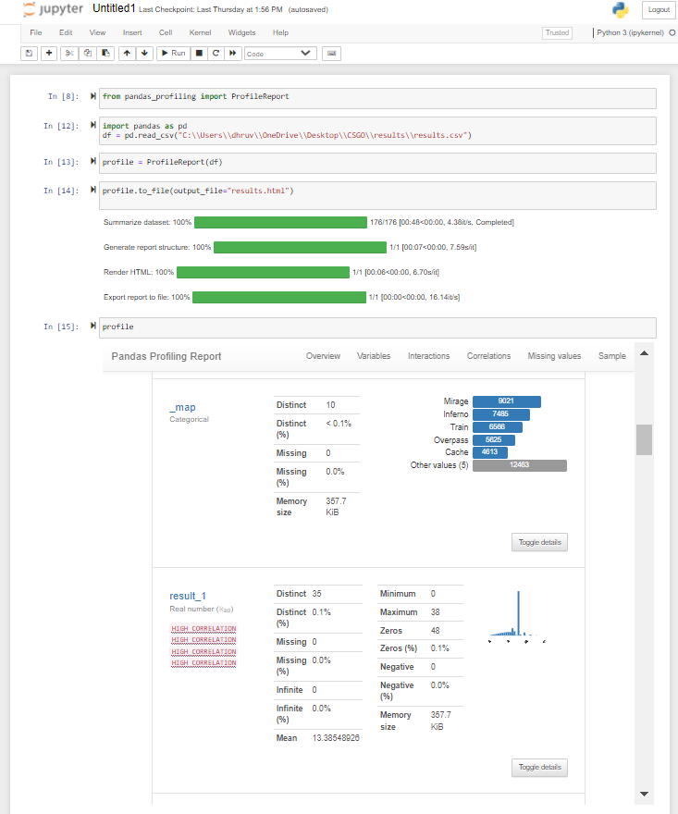

Above screenshots shows the analysis part done by Python

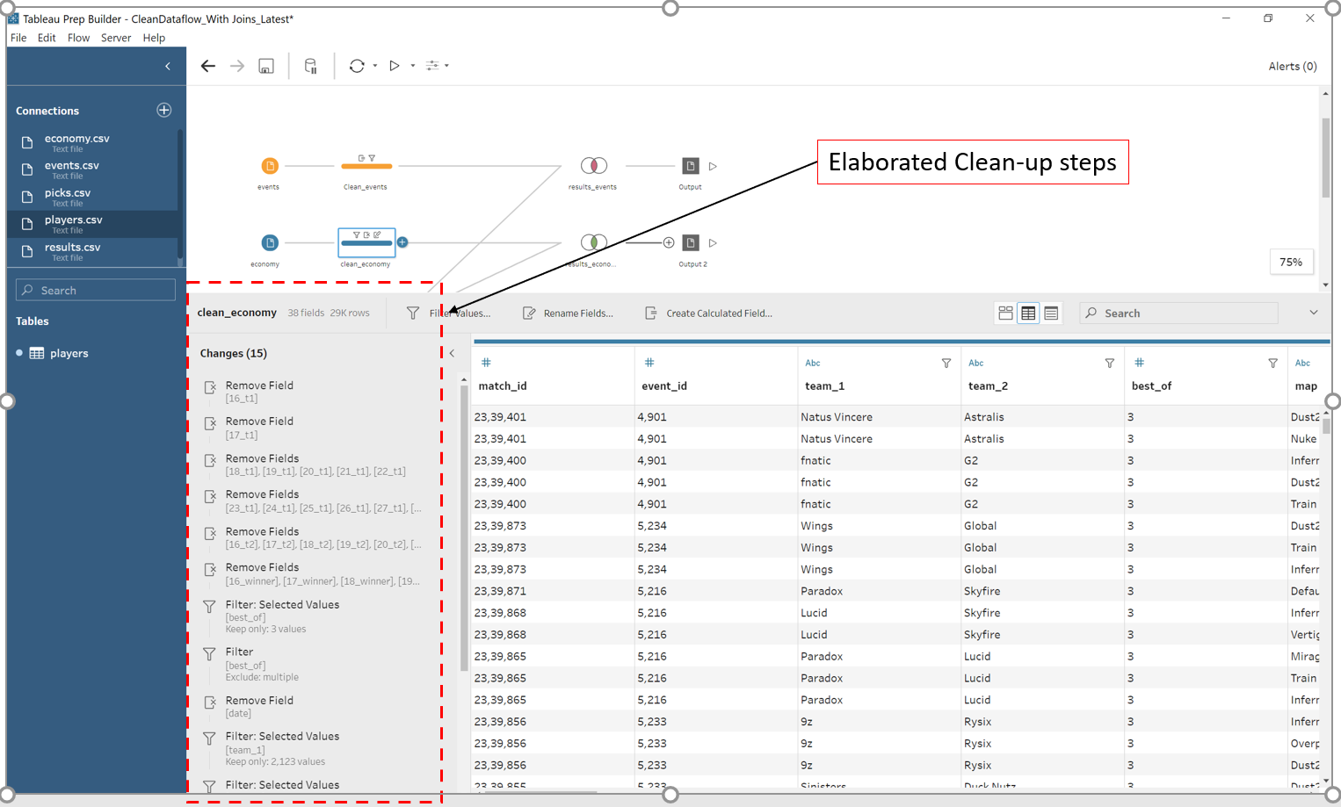

Tableau Prep cleanup screen shows various steps applied on the raw csv file to cleanup data. Steps related to removing columns and filtering values can be seen in the above screenshot
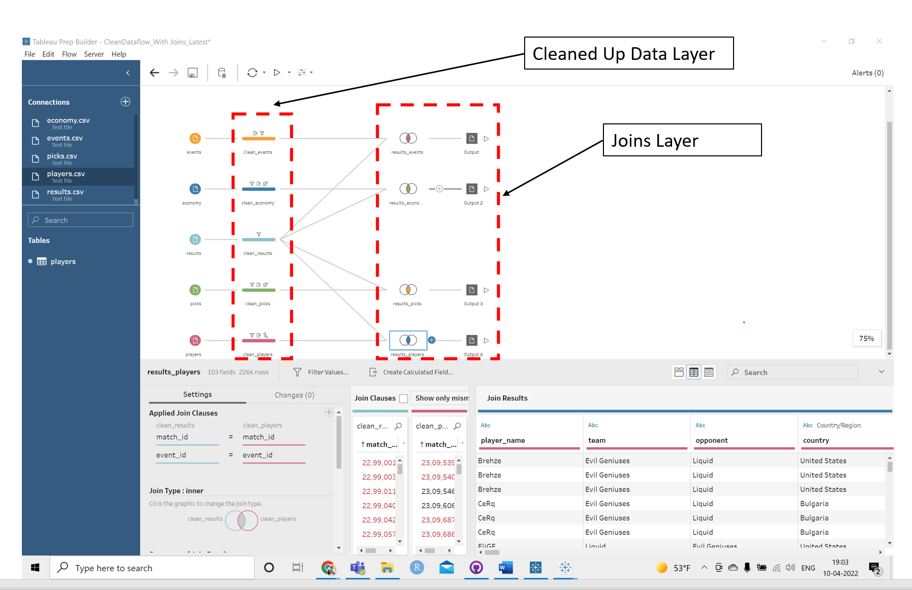

Above Tableau Prep screen shows various Joins that have been put up in Fact and Dim tables. The data from these Joins can be directly fed into Tableau Desktop to create visualisations

Joins Data Link: https://github.com/miners-work/DAB-103-Project/tree/main/Clean_Joined_Data
Dataflow code: https://github.com/miners-work/DAB-103-Project/tree/main/Code/TableauPrep_Flows

- Data Analysis

Version

- GIT Setup

Team has tried using Version control for initial documentation level. A shared GIT Repo is created for the team members to add and update documents. This repo will be further used to add code and visualization part.
- https://github.com/miners-work/DAB-103-Project
- References

Below mentioned are the websites and links that were used/referenced during the analysis till now:
- Data set directory, Kaggle was explored for multiple data sets and to gain insights regarding different datasets, also column details were used for EDA analysis: https://www.kaggle.com/datasets/mateusdmachado/csgo-professional-matches?select=results.csv
- Generic Proposal Template for headers and content: Generic Project Proposal Template - Casual.pm
- Logo for the team, was derived from the below website: https://www.canva.com/q/pro/?utm_source=google_sem&utm_medium=cpc&utm_campaign=REV_CA_EN_CanvaPro_Branded_Tier1_Core_EM&utm_term=REV_CA_EN_CanvaPro_Branded_Tier1_Canva_EM&utm_content=358_control&gclid=CjwKCAjwxOCRBhA8EiwA0X8hiwLGbNQbY7mfXqwBIPHJpf8nsWgp0jsCEJ6iQTRehEpI1wci99YBpRoCjzUQAvD_BwE&gclsrc=aw.ds
- Source control was practiced in the team for the document sharing and updates – helped a lot in tracking changes and sharing insights to all team members: https://github.com/
- Spreadsheets were extensively used for EDA analysis – for Data derivation, Outliers, Graphs, and initial visualizations: Microsoft Excel

